Task 1: Develop a C program that demonstrates how a Linux operating system executes a command entered by a user that 1. Accept a Linux command as input. 2. Create a child process using fork(). 3. Execute the command in the child process using an appropriate exec() system call. 4. Allow the parent process to wait for the child using wait (). 5. Display the Process ID (PID) of both parent and child processes.
- Write a C code to create a process using fork() system call.
- Read the user input as shell command.
- Use a system call exec() to execute the shell command.
- Use a wait() system call for waiting a parent process.
- Display the PIDs of parent and child processes.

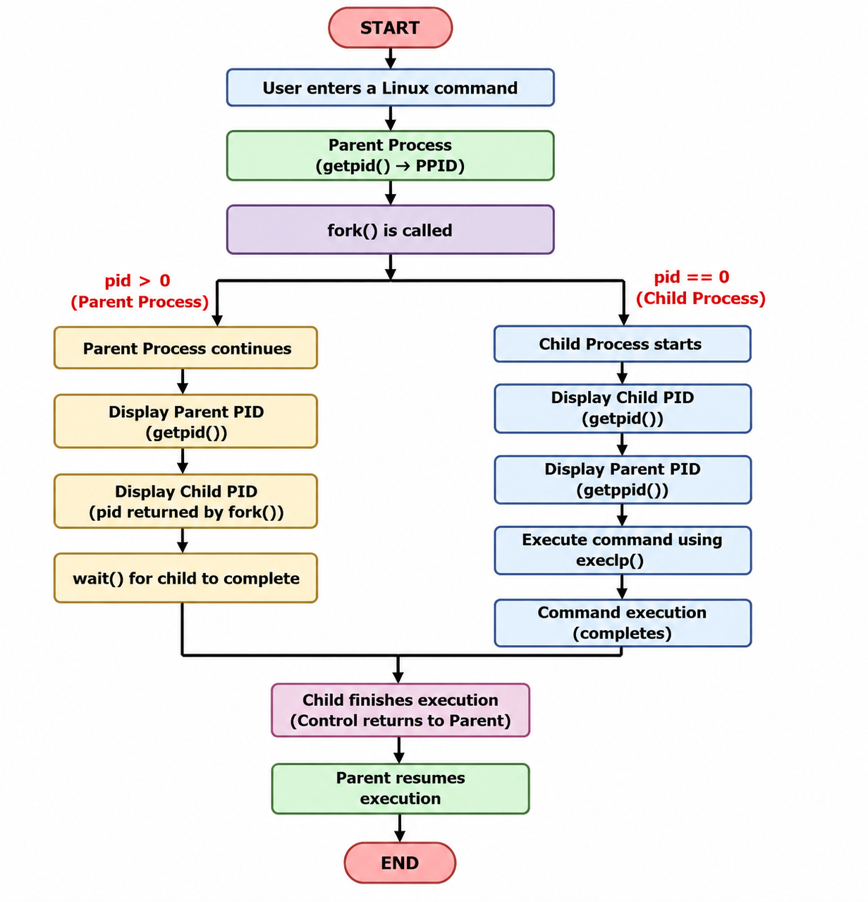

Example Output:
Enter a Linux command: ls
Parent Process
Child Process
Parent PID : 67
Child PID : 68
Child PID : 68
Parent PID : 67

Executing command: ls
CE1 FIRST.c File2.c Proces_States.c command_executor filecopy.c hello.c process_example session_4_a session_4_b.c
CE1.c File1.c First.c Process_States.c command_executor.c fork_example.c.save my_shell process_example.c session_4_a.c
FIRST File1.txt Proces_States R1 filecopy hello os-lab process_example.cyes session_4_b
Child process completed.
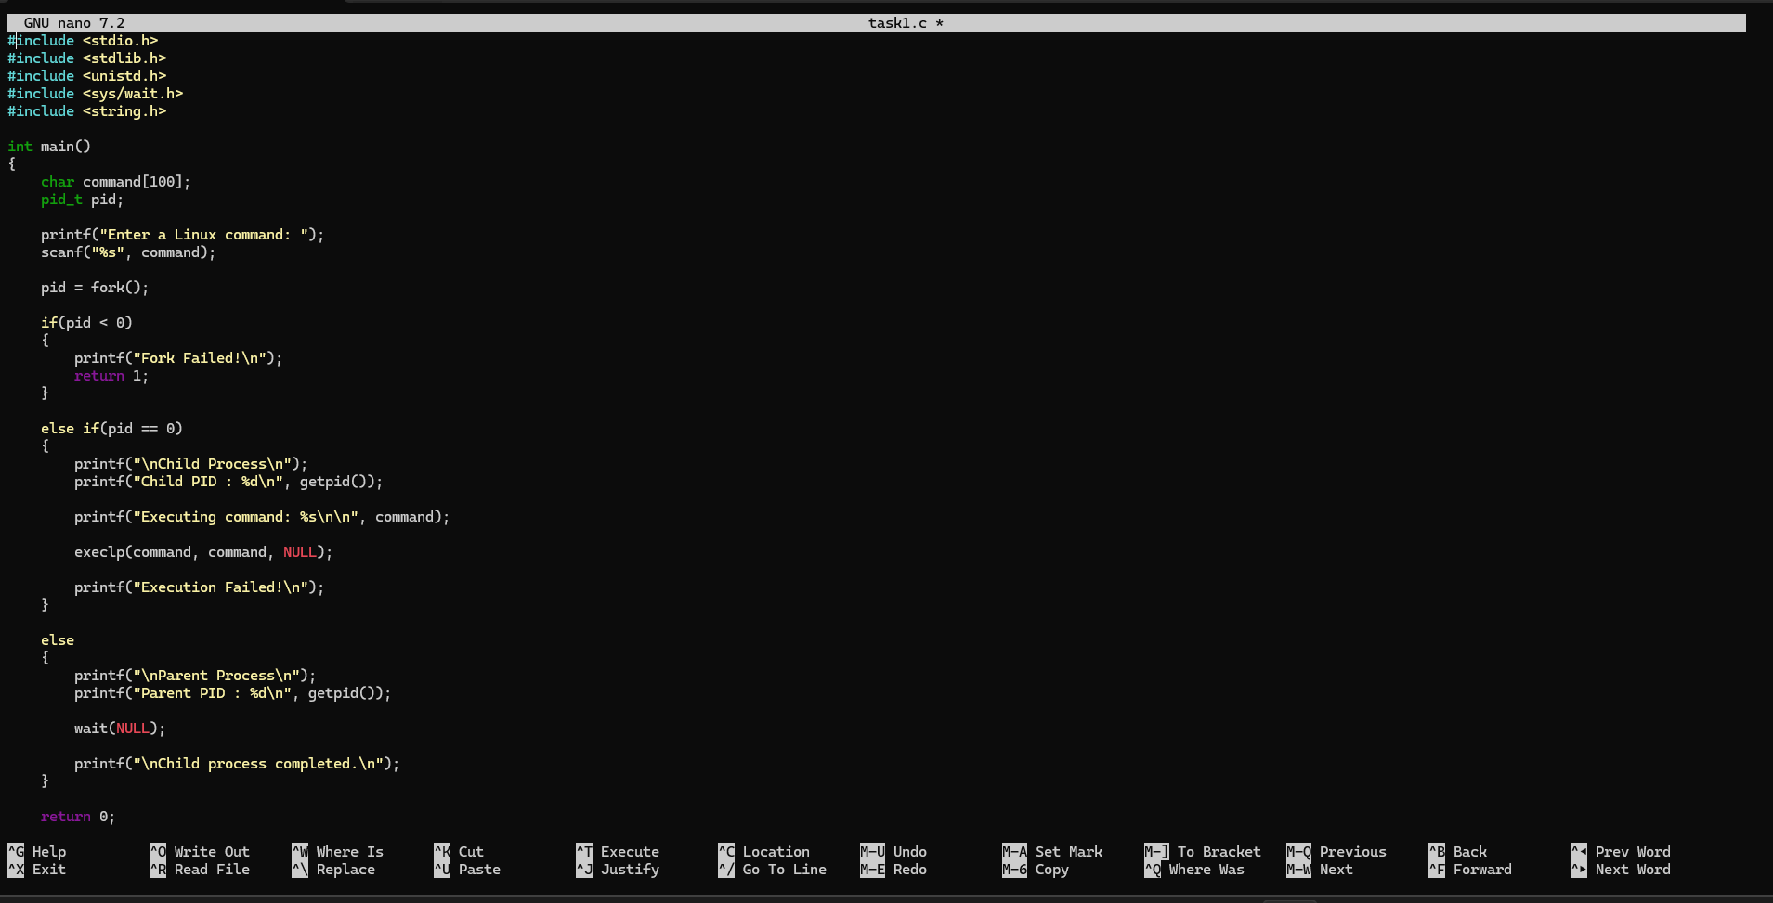
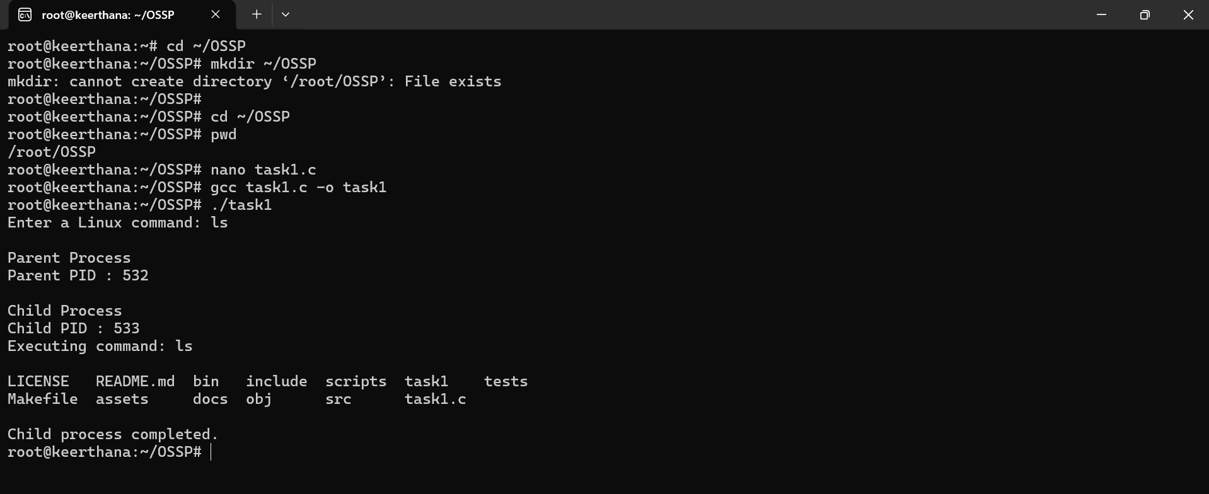

Task-2: Using Linux terminal commands (uname, lscpu, ps, top), investigate the relationship between hardware resources and operating system services. Prepare a report explaining how the OS abstracts CPU, memory, storage, and I/O devices.
1.Uname
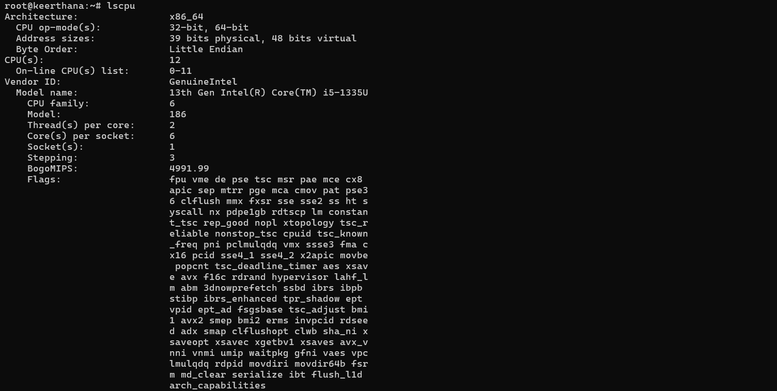
2.Lspu

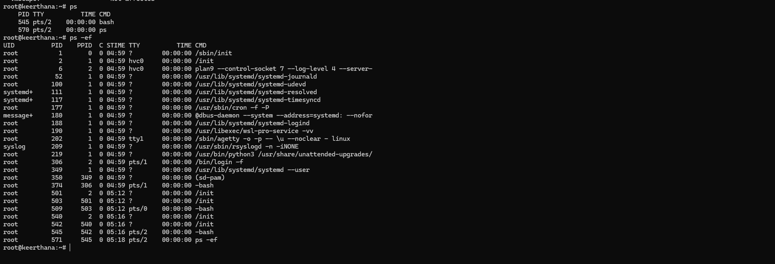
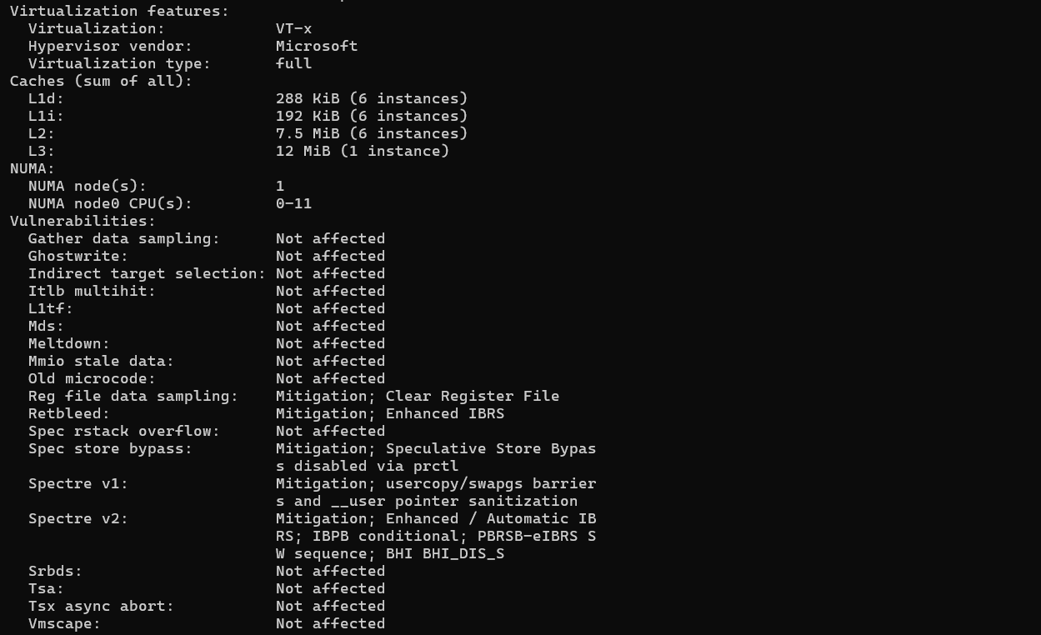
3.Ps
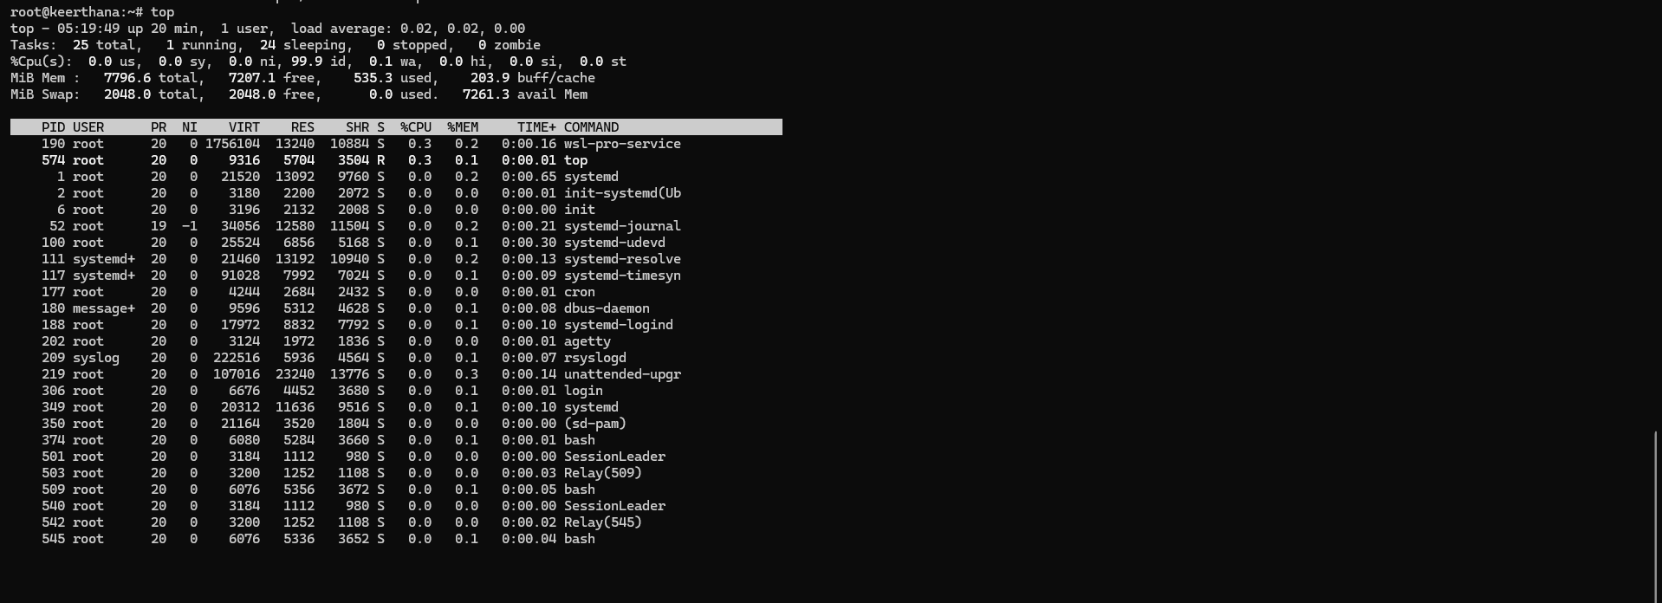
4.Top

